Name:- Document-5
Solution:-
CORS (Cross-Origin Resource Sharing) is a security feature in browsers that blocks requests from other origins (like frontend running on http://localhost:3000 accessing API on https://localhost:5001).
To enable access, you need to enable CORS in your API.
Updated Program.cs

using Microsoft.AspNetCore.Authentication.JwtBearer;
using Microsoft.IdentityModel.Tokens;
using System.Text;

var builder = WebApplication.CreateBuilder(args);

builder.Services.AddCors(options =>
{
options.AddPolicy("AllowAll", policy =>
{
policy.AllowAnyOrigin().AllowAnyHeader().AllowAnyMethod();
});
});

builder.Services.AddControllers();
builder.Services.AddEndpointsApiExplorer();
builder.Services.AddSwaggerGen();

string securityKey = "mysuperdupersecretkeyforJWTtoken@123";
var symmetricSecurityKey = new SymmetricSecurityKey(Encoding.UTF8.GetBytes(securityKey));

builder.Services.AddAuthentication(x =>
{
x.DefaultAuthenticateScheme = JwtBearerDefaults.AuthenticationScheme;
x.DefaultChallengeScheme = JwtBearerDefaults.AuthenticationScheme;
}).AddJwtBearer(options =>
{
options.TokenValidationParameters = new TokenValidationParameters
{
ValidateIssuer = true,
ValidateAudience = true,
ValidateLifetime = true,
ValidateIssuerSigningKey = true,
ValidIssuer = "mySystem",
ValidAudience = "myUsers",
IssuerSigningKey = symmetricSecurityKey
};
});

var app = builder.Build();

app.UseSwagger();
app.UseSwaggerUI();
app.UseHttpsRedirection();
app.UseCors("AllowAll");
app.UseAuthentication();
app.UseAuthorization();
app.MapControllers();
app.Run();

Create AuthController.cs in Controolers folder

using Microsoft.AspNetCore.Authorization;
using Microsoft.AspNetCore.Mvc;
using Microsoft.IdentityModel.Tokens;
using System.IdentityModel.Tokens.Jwt;
using System.Security.Claims;
using System.Text;

namespace WorkingSwaggerDemo.Controllers
{
[Route("api/[controller]")]
[ApiController]
[AllowAnonymous]
public class AuthController : ControllerBase
{
[HttpGet]
public IActionResult GetToken()
{
var token = GenerateJSONWebToken(1, "Admin");
return Ok(new { token });
}

private string GenerateJSONWebToken(int userId, string userRole)
{
var securityKey = new SymmetricSecurityKey(Encoding.UTF8.GetBytes("mysuperdupersecretkeyforJWTtoken@123"));
var credentials = new SigningCredentials(securityKey, SecurityAlgorithms.HmacSha256);

var claims = new List<Claim>
{
new Claim(ClaimTypes.Role, userRole),
new Claim("UserId", userId.ToString())
};

var token = new JwtSecurityToken(
issuer: "mySystem",
audience: "myUsers",
claims: claims,
expires: DateTime.Now.AddMinutes(2),
signingCredentials: credentials);

return new JwtSecurityTokenHandler().WriteToken(token);
}
}
}

Updated Code for EmployeeController.cs in Controllers Folder for Authorization:

using Microsoft.AspNetCore.Authorization;
using Microsoft.AspNetCore.Mvc;
using WorkingSwaggerDemo.Models;

namespace WorkingSwaggerDemo.Controllers
{
[Route("api/[controller]")]
[ApiController]
[Authorize(Roles = "Admin")]
public class EmployeeController : ControllerBase
{
private static List<Employee> employees = new List<Employee>
{
new Employee
{
Id = 1,
Name = "Mickey",
Salary = 60000,
Permanent = true,
DateOfBirth = new DateTime(1999, 10, 10),
Department = new Department { Id = 101, Name = "Engineering" },
Skills = new List<Skill>
{
new Skill { Id = 1, Name = "ASP.NET" },
new Skill { Id = 2, Name = "Swagger" }
}
}
};

[HttpGet]
public ActionResult<IEnumerable<Employee>> GetAll()
{
return Ok(employees);
}

[HttpGet("{id}")]
public ActionResult<Employee> GetById(int id)
{
var emp = employees.FirstOrDefault(e => e.Id == id);
if (emp == null) return NotFound("Employee not found");
return Ok(emp);
}

[HttpPut("{id}")]
public ActionResult<Employee> UpdateEmployee(int id, [FromBody] Employee updated)
{
if (id <= 0) return BadRequest("Invalid employee id");

var emp = employees.FirstOrDefault(e => e.Id == id);
if (emp == null) return BadRequest("Invalid employee id");

emp.Name = updated.Name;
emp.Salary = updated.Salary;
emp.Permanent = updated.Permanent;
emp.Department = updated.Department;
emp.Skills = updated.Skills;
emp.DateOfBirth = updated.DateOfBirth;

return Ok(emp);
}
}
}

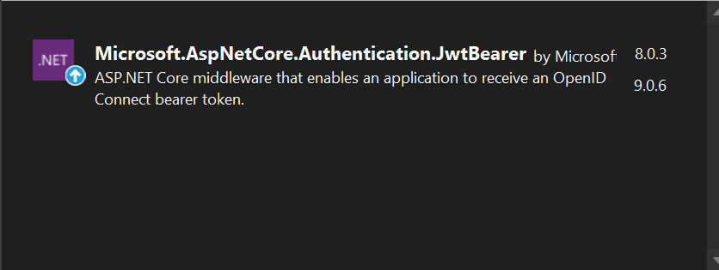

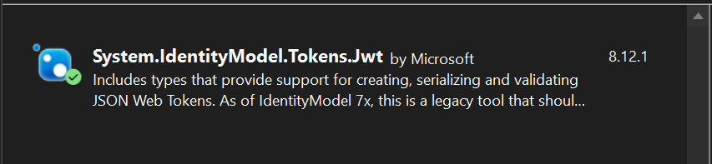

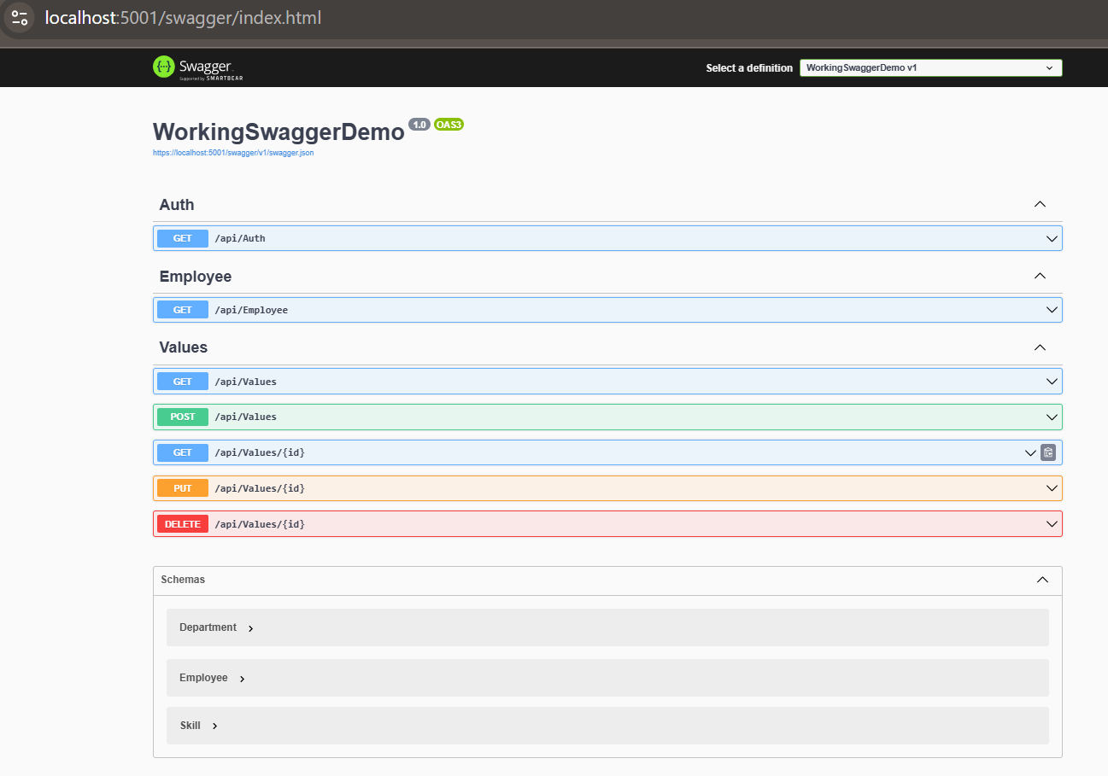

Use Postman to Test

The View of local host

